Symplicity Experiential Learning Application – Student Instructions for Externship:
- Go to https://una-csm.symplicity.com. Log in to your Symplicity account using your UNA Portal username and password.
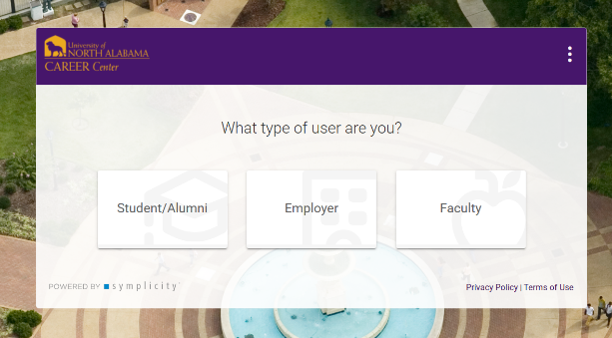
- Once logged in, click on the Experiential Learning tab.
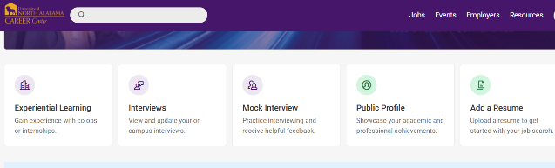
- From here, you will have the opportunity to create new experiential learning logs or review existing logs. To begin, click Add New. Fill in as much information as possible on your EL Application. Make sure to fill in all required fields. Make sure to pay close attention to the small print.
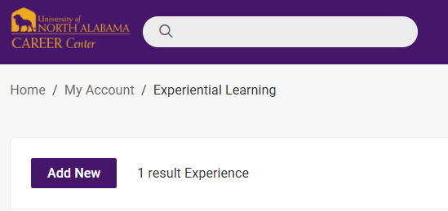
- Select the Experiential Learning Type. It is very important that you select the correct Experiential Learning Type. Please note that there are many different Experiential Learning types, so be sure to choose the correct one. If you are logging a job shadowing experience, the Experiential Learning Type will be Job Shadow.
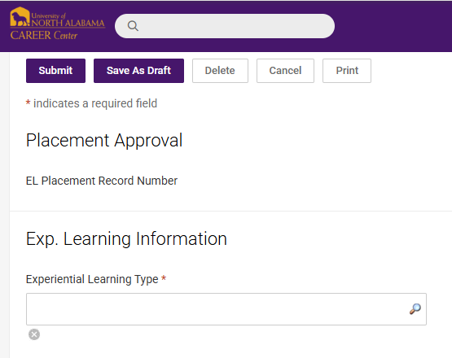

- Fill in the Employer information fields and the Job Title field.
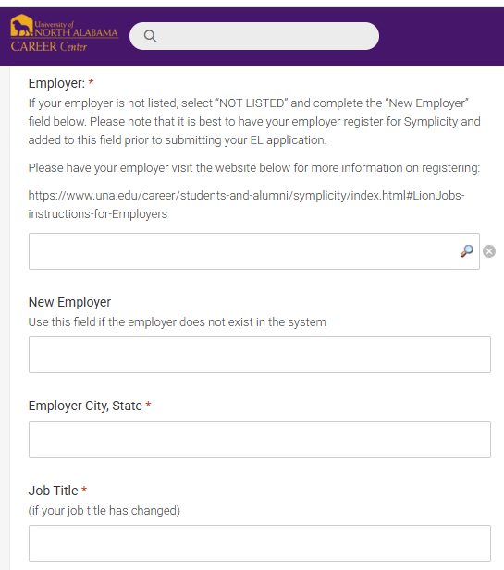
- Select the Work Term.
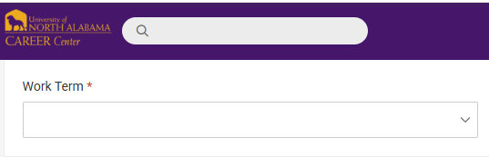
- Answer the following questions and select the Start Date, End Date, and the Enroll Date (if applicable). The Enroll Date is the date that you enrolled at UNA.
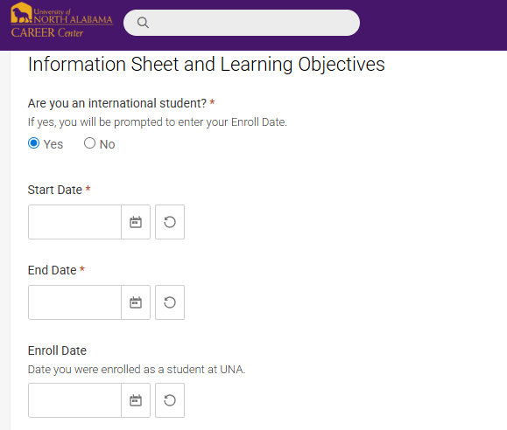
- Select the Compensation Type.
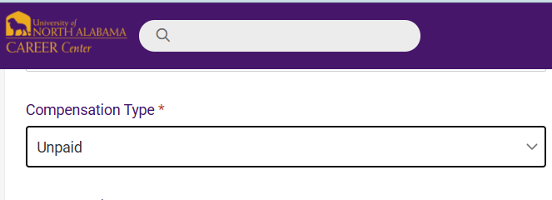
- Provide your Supervisor’s Name, Phone Number, and Email Address.
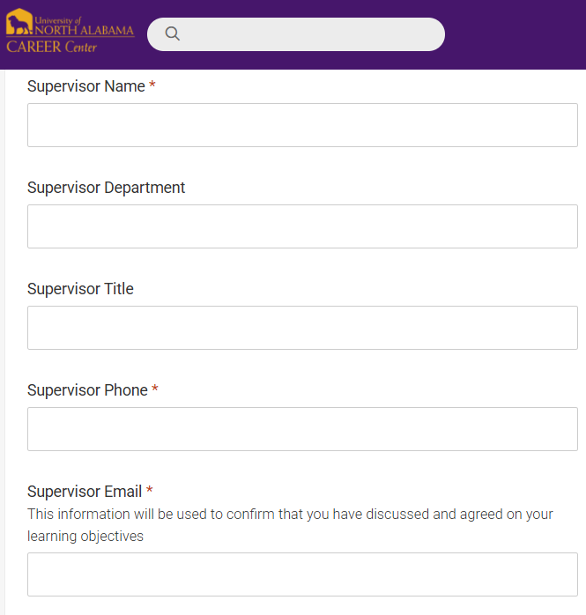
- Upload and attach required documents such as MOU forms here.
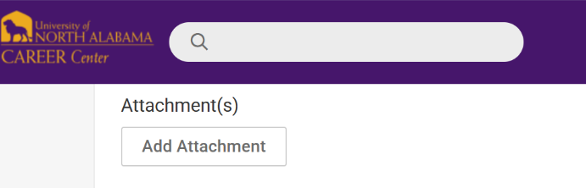
- Sign your name in the Student Agreement Signature field.
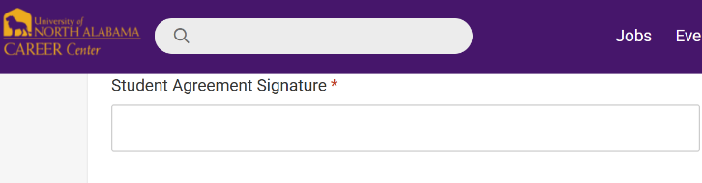
- You can save your data and come back to work on it later by clicking Save As Draft. Once you complete your EL Application, click Submit. Once you hit Submit, your EL Application will go to the appropriate approvers for review. Please note that you will not be able to track your hours until your placement data is approved. Once your EL Application is approved, you will be able to track your hours.
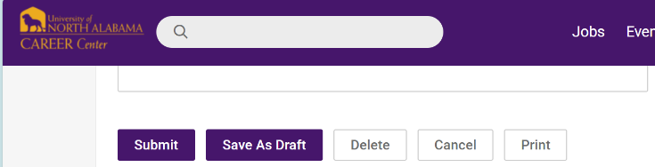

Tracking your hours once your placement data is approved:
- Go to Symplicity and click on the Experiential Learning tab.
- Click on Track Hours.
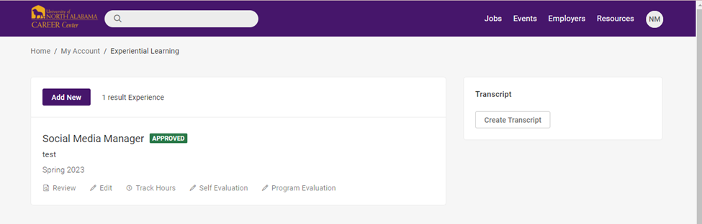
- From here you can log how many hours you worked during a specific time period and list any responsibilities you had. To do so, click Add Hours and fill in the required fields. Click submit when finished. You can make edits to hour logs if needed.
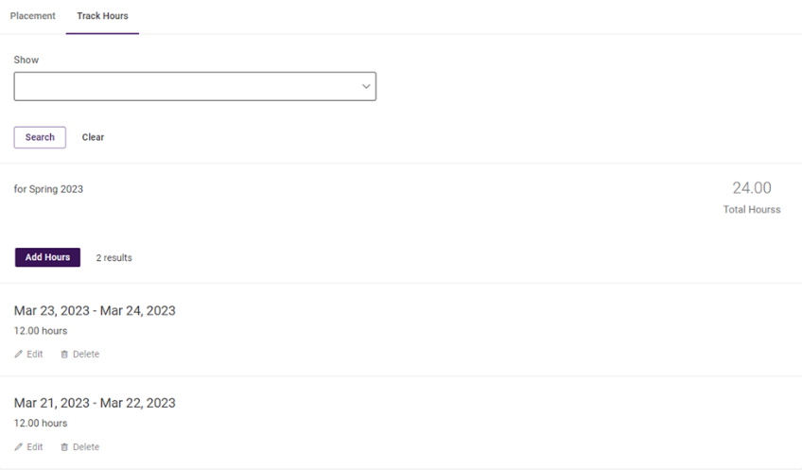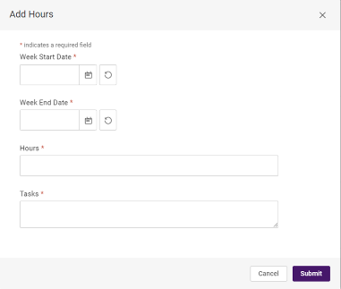

Additional Information:
- If you have questions about Symplicity or need help with your EL application, please make a General Assistance appointment with the Experiential Learning Career Coach or another UNA Career Center staff member. Find the link to the UNA Career Center’s booking page below:
https://unacareer.youcanbook.me/
- If your Employer/Supervisor needs more information on creating a Symplicity account, they can find more information here:
https://una.edu/career/students-and-alumni/symplicity/index.html#LionJobs-instructions-for-Employers
- Find a link to the MOU form below:
https://www.una.edu/career/experiential-learning/docs/una-experential-learning-program-memorandum.pdf#Experiential%20Learning%20Application
- You can create transcripts for your Experiential Learning experiences. You can choose which experiences you would like to include. All you need to do is click Create Transcript and select the experiences of your choosing and click Submit.

